Database Basics and SQL Teaching Handbook
Clean classroom notes for teaching DBMS fundamentals, database types, relational concepts, keys, SQL categories, DDL, DML, DCL, and a complete school project in MySQL.
Designed as an editable trainer document
Includes worked examples and query patterns
Ends with a practical school database project

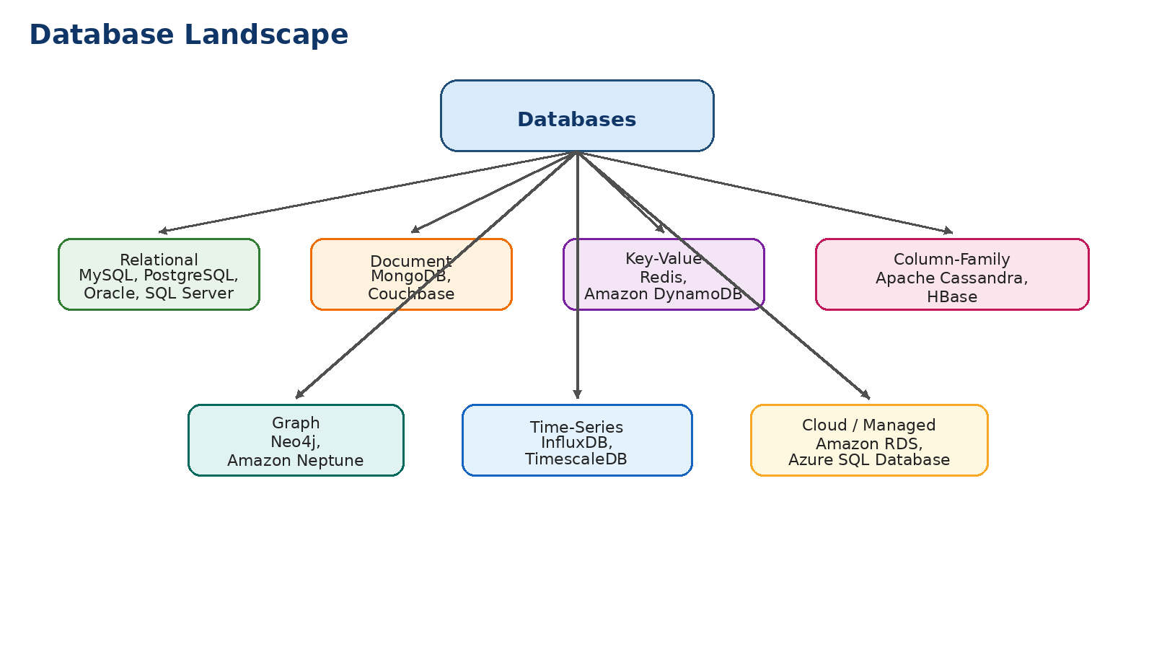

Contents
01. 1. Database basics and why DBMS is used
02. 2. File system vs DBMS
03. 3. DBMS architecture at a glance
04. 4. Types of databases with real product examples
05. 5. Core relational database terms
06. 6. Keys in relational databases
07. 7. Constraints and data integrity
08. 8. SQL categories: DDL, DML, DQL, DCL, TCL
09. 9. Common SQL data types
10. 10. DDL statements with example queries
11. 11. DML statements with example queries
12. 12. DCL statements with example queries
13. 13. SELECT, filtering, sorting, grouping and joins
14. 14. Views, indexes and transactions
15. 15. Normalization basics
16. 16. Common beginner mistakes
17. 17. School project: schema, MySQL tables, sample data and reports
18. 18. Practice exercises and classroom discussion prompts

1. Database basics and why DBMS is used
A database is an organized collection of data that can be stored, searched, updated and protected in a controlled way. In practical systems, a database is used to keep business data consistent and available for many users at the same time.
A DBMS, or Database Management System, is the software layer that helps users and applications create databases, define structure, insert data, retrieve data, secure access and manage backup or recovery.
Examples from daily life include student records in a school, bank accounts and transactions in a bank, customer orders in an e-commerce platform, appointment history in a hospital and employee payroll in a company.
• Data is stored in an organized structure instead of scattered files.
• Multiple users can work on the same system safely.
• Security, permissions and backup are easier to manage.
• Large datasets can be searched and reported quickly.
• Relationships between data items can be enforced through keys and constraints.
Trainer note: Begin class with real systems students already know: ATM, Amazon order history, school report cards, library management and WhatsApp contacts.

Why this matters: A database is not just storage. It combines structure, rules, access control and query capability.

2. File system vs DBMS
Before DBMS became common, many applications stored records in separate files. That method works only for very small systems. As data volume and user count increase, file-based storage causes duplication, inconsistency and weak control.
Aspect | File system | DBMS
Data duplication | Common | Reduced through structure and normalization
Searching | Manual or program-specific | Query language support
Multi-user access | Difficult | Built-in concurrency handling
Security | Limited | Users, roles and permissions
Backup and recovery | Manual | Supported by database tools
Relationships | Hard to enforce | Managed through keys and constraints

A file system is still useful for unstructured files such as images, PDFs and videos. But when the application needs structured records, relationships and controlled updates, DBMS is the better option.
Trainer note: Students understand this section quickly if you compare a folder of Excel files with a proper school ERP database.

3. DBMS architecture at a glance
DBMS architecture explains how users, applications and the database engine interact. At a simple level, users or applications send SQL commands. The DBMS parses the query, checks permissions, reads or changes stored data and returns results.
• Client: user interface or application that sends requests.
• DBMS engine: parses SQL, optimizes query execution and manages storage.
• Storage: data files, index files and logs used for recovery.
• Metadata / catalog: structure information about tables, columns, keys and constraints.
Component | Purpose | Example
Parser | Understands SQL syntax | Checks whether CREATE TABLE or SELECT is valid
Optimizer | Chooses an efficient execution plan | Decides whether to use index or full scan
Transaction manager | Maintains consistency | Commit and rollback
Storage manager | Reads and writes data blocks | Table and index storage
Security manager | Controls access | GRANT and REVOKE

Why this matters: Even though students are learning basics, a light introduction to parser, optimizer and transaction manager helps them understand why SQL feels powerful.

4. Types of databases with real product examples
Not all databases are designed in the same way. Database type depends on the data model, scale, speed requirements and how the application uses data.

Figure: major database categories and well-known product names
4.1 Relational databases
Relational databases store data in tables made of rows and columns. Relationships between tables are managed through primary keys and foreign keys.
These databases are best when the data has clear structure and the business rules must be strongly enforced.
• MySQL – widely used in web applications and training projects
• PostgreSQL – strong standards support and advanced features
• Oracle Database – common in large enterprise systems
• Microsoft SQL Server – popular in corporate and reporting environments
• MariaDB – community-driven relational database compatible with MySQL in many cases
4.2 Document databases
Document databases store records as JSON-like documents. They are useful when records vary in structure.
• MongoDB – common for flexible web and mobile applications
• Couchbase – document database with caching and scale support
4.3 Key-value databases
A key-value database stores each value against a unique key. This model is very fast for lookup-heavy scenarios.
• Redis – often used for caching, sessions and fast lookups
• Amazon DynamoDB – managed cloud key-value and document database
4.4 Column-family databases
Column-family databases are designed for large-scale distributed workloads and write-heavy systems.
• Apache Cassandra – high availability across many servers
• HBase – column-family storage in big-data environments
4.5 Graph databases
Graph databases focus on relationships such as friends, routes, recommendations or fraud connections.
• Neo4j – popular for graph modeling and relationship queries
• Amazon Neptune – managed cloud graph database
4.6 Time-series and specialized databases
• InfluxDB – time-stamped monitoring and sensor data
• TimescaleDB – PostgreSQL-based time-series solution
• Snowflake – cloud data platform for analytics
• BigQuery – serverless analytical database on Google Cloud
Trainer note: Teach database type selection with use cases: student ERP -> relational; cache -> Redis; social network relationships -> graph; IoT sensor data -> time-series.

5. Core relational database terms
The relational model uses simple building blocks, but students should learn the correct terms early.
Term | Meaning | Example
Table | Collection of related rows | Students
Row / record / tuple | One stored item | One student
Column / field / attribute | Property of an item | student_name
Domain | Allowed values for a column | Only valid dates in a date column
Schema | Design or structure of database | All tables and relationships
Relationship | Connection between tables | Marks linked to Students

A well-designed relational database avoids duplicate storage of the same fact and uses relationships to connect related information.
Why this matters: Students often mix up schema, table and database. Clarify that database is the container, schema is the design, and tables are the actual structures.

6. Keys in relational databases
Keys are columns or sets of columns used to identify rows uniquely or connect tables. They are essential for data integrity.
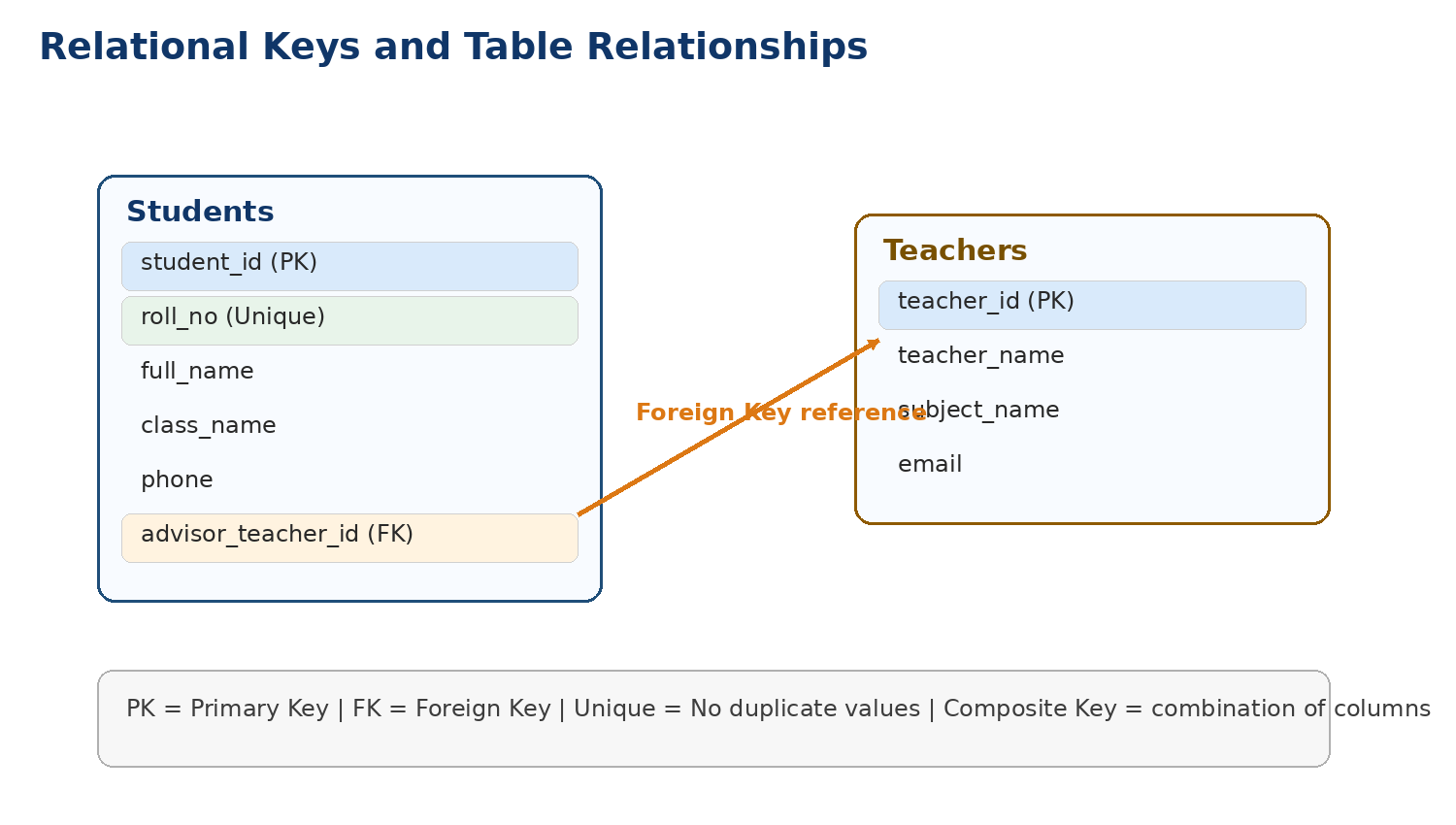
Figure: primary key, unique key and foreign key in a simple relationship
Key type | Meaning | Example
Primary key | Uniquely identifies each row; cannot be NULL | student_id
Candidate key | A column or column set that can uniquely identify a row | student_id, roll_no
Alternate key | Candidate key not chosen as primary key | roll_no
Composite key | Key formed by more than one column | (student_id, test_id)
Foreign key | Column that references primary key in another table | marks.student_id -> students.student_id
Surrogate key | Artificial generated key | auto-increment id
Natural key | Key that already exists in business data | email, Aadhaar-like code, roll number

In most practical applications, a surrogate primary key is used for simplicity, while business columns such as roll number or email are protected with UNIQUE constraints.
Trainer note: Use one classroom example throughout: students, teachers, tests and marks. Reusing the same example reduces confusion.

7. Constraints and data integrity
Constraints are rules defined on a table so that incorrect data is blocked before it is stored.
• NOT NULL – column must always have a value
• UNIQUE – duplicate values are not allowed
• PRIMARY KEY – unique row identity
• FOREIGN KEY – value must exist in the referenced parent table
• CHECK – value must satisfy a condition
• DEFAULT – if user does not provide a value, database fills a default
Constraint | Purpose | Example
NOT NULL | Avoid blank critical values | student_name VARCHAR(100) NOT NULL
UNIQUE | Avoid duplicates | email VARCHAR(120) UNIQUE
CHECK | Keep values in range | fee_due >= 0
DEFAULT | Apply standard value | status DEFAULT 'ACTIVE'
FOREIGN KEY | Protect relationship | teacher_id references teachers

Why this matters: Constraints are not optional decoration. They are the first line of data quality protection.

8. SQL categories: DDL, DML, DQL, DCL and TCL
SQL is usually grouped by purpose. Teaching these categories first helps students understand why different commands exist.
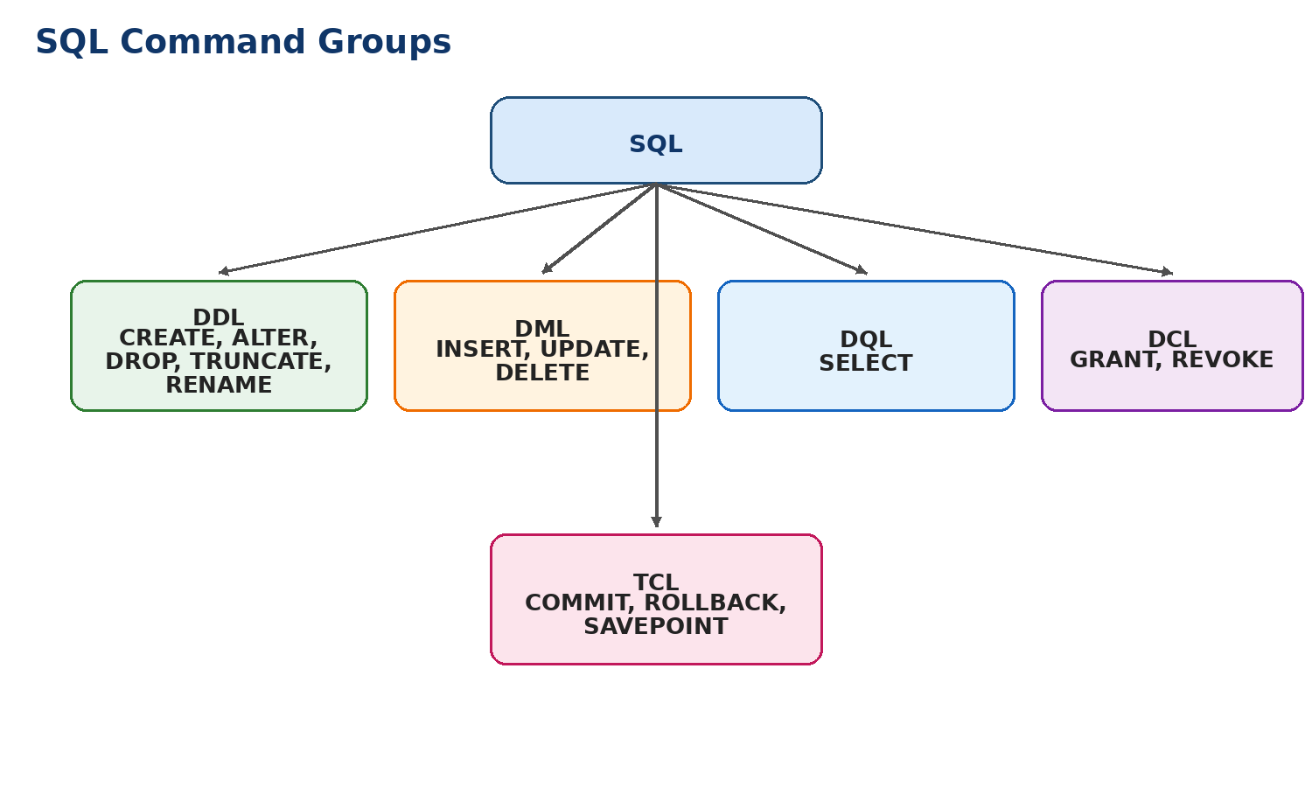
Figure: SQL command groups
• DDL (Data Definition Language): structure-related commands such as CREATE, ALTER, DROP, TRUNCATE and RENAME
• DML (Data Manipulation Language): data-changing commands such as INSERT, UPDATE and DELETE
• DQL (Data Query Language): SELECT statements for reading data
• DCL (Data Control Language): access control commands such as GRANT and REVOKE
• TCL (Transaction Control Language): transaction commands such as COMMIT, ROLLBACK and SAVEPOINT

9. Common SQL data types
Students should know common MySQL data types before writing DDL statements.
Data type | Used for | Example
INT | Whole numbers | student_id, max_marks
DECIMAL(10,2) | Exact decimal values | fee_due
VARCHAR(n) | Short variable-length text | student_name, email
CHAR(n) | Fixed-length text | Gender code or status code
DATE | Calendar date | test_date
DATETIME | Date and time | created_at
TEXT | Long text | remarks
BOOLEAN / TINYINT(1) | True/false style values | is_active

Data type choice affects storage, validation and performance. For currency-like values, DECIMAL is safer than FLOAT because exact values are preserved.

10. DDL statements with example queries
10.1 CREATE DATABASE and USE
CREATE DATABASE school_db;
USE school_db;

CREATE DATABASE creates a new database container. USE selects that database for further commands.
10.2 CREATE TABLE
CREATE TABLE students (
student_id INT PRIMARY KEY AUTO_INCREMENT,
roll_no VARCHAR(20) NOT NULL UNIQUE,
student_name VARCHAR(100) NOT NULL,
class_name VARCHAR(20) NOT NULL,
guardian_name VARCHAR(100),
phone VARCHAR(15),
email VARCHAR(120) UNIQUE,
fee_due DECIMAL(10,2) DEFAULT 0.00
);

10.3 ALTER TABLE
ALTER TABLE students
ADD admission_date DATE;
ALTER TABLE students
MODIFY phone VARCHAR(20);
ALTER TABLE students
ADD status VARCHAR(15) DEFAULT 'ACTIVE';

ALTER TABLE changes an existing table without recreating it. It can add, modify or remove columns and constraints.
10.4 RENAME, TRUNCATE and DROP
RENAME TABLE students TO student_master;
TRUNCATE TABLE student_master;
DROP TABLE student_master;

• RENAME changes the table name.
• TRUNCATE removes all rows quickly but keeps the table structure.
• DROP removes the table structure and its data completely.
Why this matters: Use TRUNCATE carefully in class demos. It removes all rows and normally cannot be reversed by ordinary undo in many setups.

11. DML statements with example queries
11.1 INSERT
INSERT INTO students
(roll_no, student_name, class_name, guardian_name, phone, email, fee_due, admission_date, status)
VALUES
('R101', 'Aarav Sharma', '10-A', 'Rohit Sharma', '9876543210', 'aarav@example.com', 1500.00, '2026-06-10', 'ACTIVE'),
('R102', 'Diya Reddy', '10-A', 'Meena Reddy', '9876501234', 'diya@example.com', 0.00, '2026-06-11', 'ACTIVE');

11.2 UPDATE
UPDATE students
SET fee_due = 500.00
WHERE roll_no = 'R101';

11.3 DELETE
DELETE FROM students
WHERE roll_no = 'R102';

11.4 INSERT ... SELECT
INSERT INTO active_students_backup (student_id, roll_no, student_name)
SELECT student_id, roll_no, student_name
FROM students
WHERE status = 'ACTIVE';

11.5 Safe teaching points
• Always use WHERE in UPDATE and DELETE unless every row must change.
• List column names explicitly in INSERT so the query is easier to maintain.
• Check data before and after a DML operation using SELECT.
Trainer note: One of the most important beginner habits is to run SELECT first, verify target rows, then run UPDATE or DELETE.

12. DCL statements with example queries
DCL controls who can access what in a database. In production systems, this is critical for safety.
CREATE USER 'school_user'@'localhost' IDENTIFIED BY 'StrongPass123';
GRANT SELECT, INSERT, UPDATE
ON school_db.*
TO 'school_user'@'localhost';
REVOKE UPDATE
ON school_db.*
FROM 'school_user'@'localhost';

• GRANT gives privileges such as SELECT, INSERT or UPDATE.
• REVOKE removes previously granted privileges.
• Good design gives each user only the permissions required for their role.
Why this matters: Use DCL more as an awareness topic in basics classes. Students do not need every privilege detail on day one, but they should know why permissions exist.

13. SELECT, filtering, sorting, grouping and joins
13.1 Basic SELECT
SELECT student_id, roll_no, student_name, fee_due
FROM students;

13.2 WHERE, ORDER BY and LIMIT
SELECT student_name, class_name, fee_due
FROM students
WHERE fee_due > 0
ORDER BY fee_due DESC
LIMIT 5;

13.3 Aggregate functions and GROUP BY
SELECT class_name,
COUNT(*) AS total_students,
SUM(fee_due) AS total_fee_due,
AVG(fee_due) AS average_fee_due
FROM students
GROUP BY class_name
HAVING SUM(fee_due) > 0;

13.4 Join types
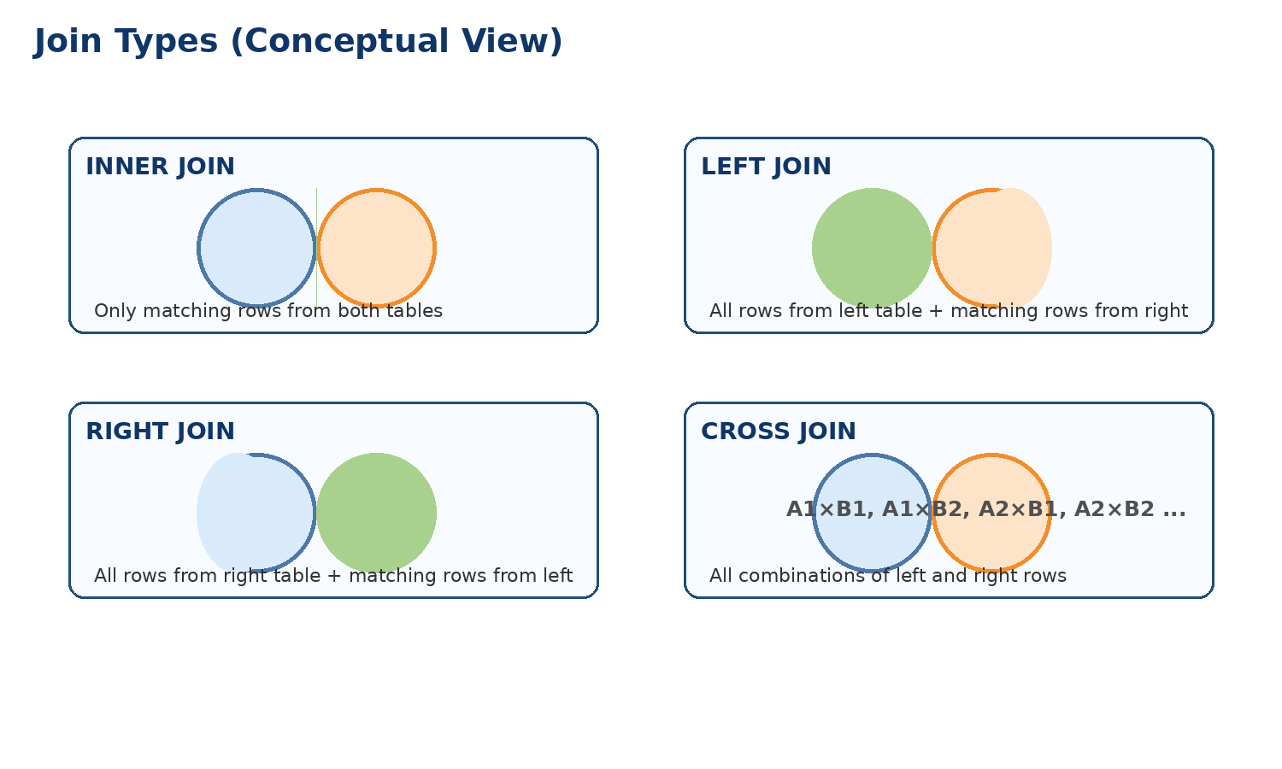
Figure: conceptual meaning of common joins
SELECT s.student_name,
t.test_name,
m.marks_obtained
FROM marks m
INNER JOIN students s ON m.student_id = s.student_id
INNER JOIN tests t ON m.test_id = t.test_id;

INNER JOIN returns only matching rows. LEFT JOIN keeps all rows from the left table even if no match exists on the right.
SELECT s.student_name, m.marks_obtained
FROM students s
LEFT JOIN marks m ON s.student_id = m.student_id;

13.5 Subquery example
SELECT student_name, fee_due
FROM students
WHERE fee_due = (
SELECT MAX(fee_due) FROM students
);

14. Views, indexes and transactions
14.1 Views
A view is a saved query that behaves like a virtual table.
CREATE VIEW vw_fee_pending AS
SELECT student_id, roll_no, student_name, fee_due
FROM students
WHERE fee_due > 0;

14.2 Indexes
Indexes improve search performance on selected columns, but they also add maintenance cost during INSERT or UPDATE.
CREATE INDEX idx_students_class
ON students(class_name);

14.3 Transactions and TCL
A transaction is a logical unit of work that should complete fully or not at all.
START TRANSACTION;
UPDATE students
SET fee_due = fee_due - 500
WHERE student_id = 1;
UPDATE students
SET fee_due = fee_due - 500
WHERE student_id = 2;
COMMIT;

START TRANSACTION;
UPDATE students
SET fee_due = -100
WHERE student_id = 1;
ROLLBACK;

Why this matters: Explain ACID informally: all-or-nothing work, valid data, safe multi-user behavior and durable save after commit.

15. Normalization basics
Normalization is the process of organizing relational data to reduce redundancy and improve consistency.
15.1 First Normal Form (1NF)
Each column should contain atomic values. A student row should not store multiple phone numbers in one comma-separated cell.
15.2 Second Normal Form (2NF)
Non-key columns should depend on the full key, especially in tables using composite keys.
15.3 Third Normal Form (3NF)
Non-key columns should not depend on other non-key columns. For example, do not store teacher phone inside every test row when it belongs to the Teachers table.
Stage | Problem reduced | Simple example
1NF | Repeating groups | Separate multiple subjects into rows or separate table
2NF | Partial dependency | Marks table should not store student_name if key is (student_id, test_id)
3NF | Transitive dependency | Store teacher contact in Teachers table, not Tests table

Trainer note: For beginners, normalization should be taught through bad table examples and then improved versions.

16. Common beginner mistakes
• Creating tables without primary keys
• Using VARCHAR for every column instead of choosing proper data types
• Forgetting NOT NULL on mandatory columns
• Running UPDATE or DELETE without WHERE
• Storing the same fact in multiple tables
• Ignoring foreign keys and then getting orphan records
• Using text values for dates and numbers
• Writing joins without understanding which column links to which table
Why this matters: Train students to ask three questions before writing SQL: What is the table? What is the key? What rows exactly should change or return?

17. School project: complete MySQL classroom project
This project is intentionally small enough for class practice and large enough to demonstrate relational design, keys, DDL, DML, joins and reporting.
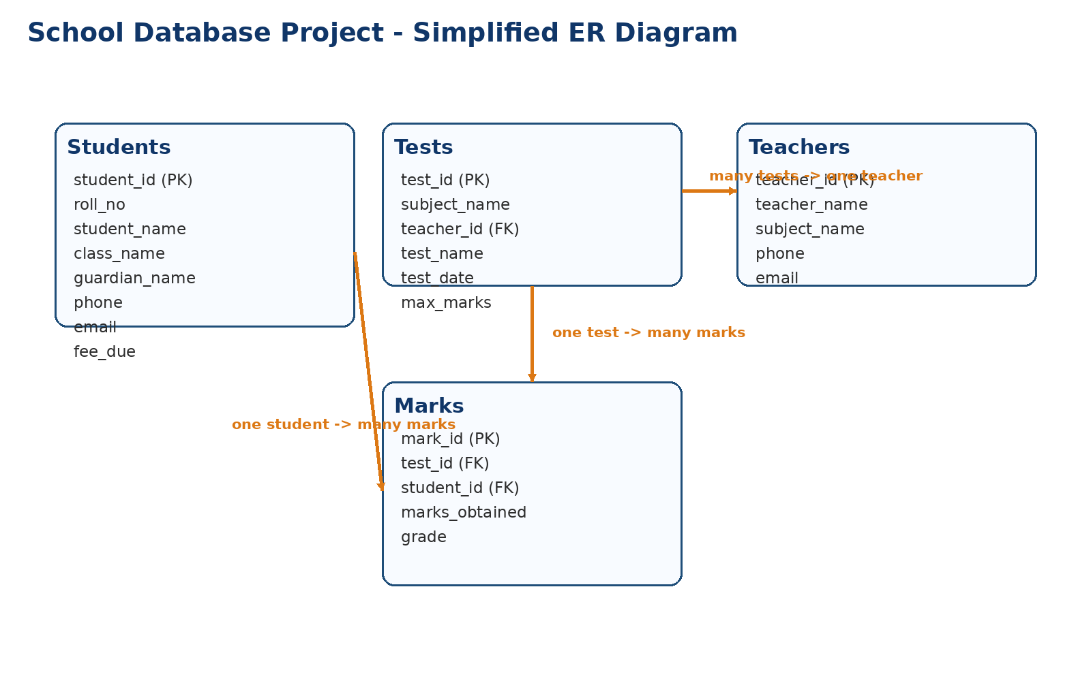
Figure: simplified ER model for the school database project
17.1 Project scope
• Store student profile and contact details
• Store teacher details with subject specialization
• Store tests conducted for each subject
• Store marks scored by each student in each test
17.2 Table design summary
Table | Purpose | Main key / relation
students | Student details, guardian contact and fee due | student_id primary key
teachers | Teacher profile and subject handled | teacher_id primary key
tests | Test/exam details | teacher_id foreign key -> teachers
marks | Student score for a test | student_id and test_id as foreign keys

18. Project MySQL DDL script
CREATE DATABASE school_project_db;
USE school_project_db;
CREATE TABLE teachers (
teacher_id INT PRIMARY KEY AUTO_INCREMENT,
teacher_name VARCHAR(100) NOT NULL,
subject_name VARCHAR(60) NOT NULL,
phone VARCHAR(15),
email VARCHAR(120) UNIQUE
);
CREATE TABLE students (
student_id INT PRIMARY KEY AUTO_INCREMENT,
roll_no VARCHAR(20) NOT NULL UNIQUE,
student_name VARCHAR(100) NOT NULL,
class_name VARCHAR(20) NOT NULL,
guardian_name VARCHAR(100),
phone VARCHAR(15),
email VARCHAR(120) UNIQUE,
fee_due DECIMAL(10,2) DEFAULT 0.00
);
CREATE TABLE tests (
test_id INT PRIMARY KEY AUTO_INCREMENT,
test_name VARCHAR(80) NOT NULL,
subject_name VARCHAR(60) NOT NULL,
teacher_id INT NOT NULL,
test_date DATE NOT NULL,
max_marks INT NOT NULL CHECK (max_marks > 0),
FOREIGN KEY (teacher_id) REFERENCES teachers(teacher_id)
);
CREATE TABLE marks (
mark_id INT PRIMARY KEY AUTO_INCREMENT,
test_id INT NOT NULL,
student_id INT NOT NULL,
marks_obtained INT NOT NULL,
grade CHAR(2),
FOREIGN KEY (test_id) REFERENCES tests(test_id),
FOREIGN KEY (student_id) REFERENCES students(student_id)
);

This design uses four tables. Subject name is stored in teachers and tests for simplicity in a beginner classroom project. In an advanced design, subject could also be moved into a separate Subjects table.

19. Project sample data (INSERT statements)
INSERT INTO teachers (teacher_name, subject_name, phone, email) VALUES
('Suma Rao', 'Mathematics', '9000011111', 'suma.rao@school.com'),
('Kiran Kumar','Science', '9000022222', 'kiran.kumar@school.com'),
('Anita Das', 'English', '9000033333', 'anita.das@school.com');
INSERT INTO students (roll_no, student_name, class_name, guardian_name, phone, email, fee_due) VALUES
('R101', 'Aarav Sharma', '10-A', 'Rohit Sharma', '9876543210', 'aarav@example.com', 1500.00),
('R102', 'Diya Reddy', '10-A', 'Meena Reddy', '9876501234', 'diya@example.com', 0.00),
('R103', 'Ishaan Patel', '10-B', 'Neha Patel', '9876512345', 'ishaan@example.com', 2500.00),
('R104', 'Sara Khan', '10-B', 'Imran Khan', '9876523456', 'sara@example.com', 500.00);
INSERT INTO tests (test_name, subject_name, teacher_id, test_date, max_marks) VALUES
('Unit Test 1', 'Mathematics', 1, '2026-07-10', 100),
('Unit Test 1', 'Science', 2, '2026-07-12', 100),
('Unit Test 1', 'English', 3, '2026-07-14', 100);
INSERT INTO marks (test_id, student_id, marks_obtained, grade) VALUES
(1, 1, 88, 'A'),
(1, 2, 76, 'B'),
(1, 3, 91, 'A'),
(1, 4, 68, 'C'),
(2, 1, 81, 'A'),
(2, 2, 73, 'B'),
(2, 3, 95, 'A'),
(2, 4, 70, 'B'),
(3, 1, 85, 'A'),
(3, 2, 79, 'B'),
(3, 3, 90, 'A'),
(3, 4, 74, 'B');

20. Project reporting queries
20.1 View all students
SELECT * FROM students;

20.2 Students with fee pending
SELECT roll_no, student_name, class_name, fee_due
FROM students
WHERE fee_due > 0
ORDER BY fee_due DESC;

20.3 Tests with teacher name
SELECT t.test_name, t.subject_name, t.test_date, t.max_marks, te.teacher_name
FROM tests t
INNER JOIN teachers te ON t.teacher_id = te.teacher_id;

20.4 Marks report with student and test details
SELECT s.roll_no,
s.student_name,
s.class_name,
t.subject_name,
t.test_name,
m.marks_obtained,
m.grade
FROM marks m
INNER JOIN students s ON m.student_id = s.student_id
INNER JOIN tests t ON m.test_id = t.test_id
ORDER BY s.student_name, t.subject_name;

20.5 Average marks by subject
SELECT t.subject_name,
AVG(m.marks_obtained) AS average_marks
FROM marks m
INNER JOIN tests t ON m.test_id = t.test_id
GROUP BY t.subject_name;

20.6 Top scorer in each subject
SELECT t.subject_name,
s.student_name,
m.marks_obtained
FROM marks m
INNER JOIN students s ON m.student_id = s.student_id
INNER JOIN tests t ON m.test_id = t.test_id
WHERE (t.subject_name, m.marks_obtained) IN (
SELECT t2.subject_name, MAX(m2.marks_obtained)
FROM marks m2
INNER JOIN tests t2 ON m2.test_id = t2.test_id
GROUP BY t2.subject_name
);

20.7 Update fee after payment
UPDATE students
SET fee_due = fee_due - 500
WHERE roll_no = 'R103';

20.8 Delete an incorrect marks entry
DELETE FROM marks
WHERE mark_id = 12;

21. Practice exercises for students
1. Write a CREATE TABLE statement for a library_members table with member_id, member_name, phone, email and join_date.
2. Add a new column named address to the students table.
3. Insert two new student records with your own sample values.
4. Show only the students from class 10-A.
5. Display students whose fee_due is greater than 1000.
6. Update phone number for a specific student using roll_no.
7. Delete one test record using test_id.
8. Find total number of students class-wise using GROUP BY.
9. Show teacher name with the tests they conduct using JOIN.
10. Display each student with marks above 80.
11. Find the highest marks in Science.
12. Create a view for fee pending students.
Trainer note: Ask learners to first identify the table, key column and condition before they start typing the SQL.

22. Trainer discussion prompts and viva questions
Q: What is the difference between a database and a DBMS?
A: A database stores organized data; a DBMS is the software used to manage it.
Q: Why do we use primary keys?
A: To identify each row uniquely and prevent duplicate row identity.
Q: What is the purpose of a foreign key?
A: To connect tables and enforce valid references between parent and child tables.
Q: What is the difference between DELETE and TRUNCATE?
A: DELETE removes selected rows and can use WHERE; TRUNCATE removes all rows quickly and keeps structure.
Q: What is DDL?
A: SQL commands that define or change database structure.
Q: What is DML?
A: SQL commands that insert, update or delete data.
Q: What is DCL?
A: SQL commands that control permissions.
Q: Why should UPDATE use WHERE?
A: Without WHERE, every row may be updated.
Q: What is normalization?
A: Organizing tables to reduce redundancy and improve consistency.
Q: Why do we create indexes?
A: To improve search performance on selected columns.

23. Quick reference: statement patterns
Statement | Pattern
CREATE TABLE | CREATE TABLE table_name (column_name datatype constraints, ...);
ALTER TABLE ADD | ALTER TABLE table_name ADD column_name datatype;
INSERT | INSERT INTO table_name (col1, col2) VALUES (val1, val2);
UPDATE | UPDATE table_name SET col1 = value WHERE condition;
DELETE | DELETE FROM table_name WHERE condition;
SELECT | SELECT col1, col2 FROM table_name WHERE condition ORDER BY col1;
JOIN | SELECT ... FROM a INNER JOIN b ON a.key = b.key;
GRANT | GRANT SELECT, INSERT ON db_name.* TO 'user'@'host';
REVOKE | REVOKE INSERT ON db_name.* FROM 'user'@'host';

This handbook is meant to be edited further by the trainer. You can add screenshots from MySQL Workbench, classroom activities or institution-specific examples wherever needed.
Why this matters: A clean beginner syllabus usually follows this order: purpose -> structure -> keys -> SQL categories -> DDL -> DML -> SELECT and joins -> project.

Trainer notes page 1
________________________________________________________________________________
________________________________________________________________________________
________________________________________________________________________________
________________________________________________________________________________
________________________________________________________________________________
________________________________________________________________________________
________________________________________________________________________________
________________________________________________________________________________
________________________________________________________________________________
________________________________________________________________________________
________________________________________________________________________________
________________________________________________________________________________
________________________________________________________________________________
________________________________________________________________________________
________________________________________________________________________________
________________________________________________________________________________
________________________________________________________________________________
________________________________________________________________________________

Trainer notes page 2
________________________________________________________________________________
________________________________________________________________________________
________________________________________________________________________________
________________________________________________________________________________
________________________________________________________________________________
________________________________________________________________________________
________________________________________________________________________________
________________________________________________________________________________
________________________________________________________________________________
________________________________________________________________________________
________________________________________________________________________________
________________________________________________________________________________
________________________________________________________________________________
________________________________________________________________________________
________________________________________________________________________________
________________________________________________________________________________
________________________________________________________________________________
________________________________________________________________________________

Trainer notes page 3
________________________________________________________________________________
________________________________________________________________________________
________________________________________________________________________________
________________________________________________________________________________
________________________________________________________________________________
________________________________________________________________________________
________________________________________________________________________________
________________________________________________________________________________
________________________________________________________________________________
________________________________________________________________________________
________________________________________________________________________________
________________________________________________________________________________
________________________________________________________________________________
________________________________________________________________________________
________________________________________________________________________________
________________________________________________________________________________
________________________________________________________________________________
________________________________________________________________________________

Trainer notes page 4
________________________________________________________________________________
________________________________________________________________________________
________________________________________________________________________________
________________________________________________________________________________
________________________________________________________________________________
________________________________________________________________________________
________________________________________________________________________________
________________________________________________________________________________
________________________________________________________________________________
________________________________________________________________________________
________________________________________________________________________________
________________________________________________________________________________
________________________________________________________________________________
________________________________________________________________________________
________________________________________________________________________________
________________________________________________________________________________
________________________________________________________________________________
________________________________________________________________________________

Trainer notes page 5
________________________________________________________________________________
________________________________________________________________________________
________________________________________________________________________________
________________________________________________________________________________
________________________________________________________________________________
________________________________________________________________________________
________________________________________________________________________________
________________________________________________________________________________
________________________________________________________________________________
________________________________________________________________________________
________________________________________________________________________________
________________________________________________________________________________
________________________________________________________________________________
________________________________________________________________________________
________________________________________________________________________________
________________________________________________________________________________
________________________________________________________________________________
________________________________________________________________________________

Trainer notes page 6
________________________________________________________________________________
________________________________________________________________________________
________________________________________________________________________________
________________________________________________________________________________
________________________________________________________________________________
________________________________________________________________________________
________________________________________________________________________________
________________________________________________________________________________
________________________________________________________________________________
________________________________________________________________________________
________________________________________________________________________________
________________________________________________________________________________
________________________________________________________________________________
________________________________________________________________________________
________________________________________________________________________________
________________________________________________________________________________
________________________________________________________________________________
________________________________________________________________________________

Appendix A. Data dictionary for the school project
A data dictionary explains what each table and column means. This is very useful in teaching because students often create tables first and only later understand why each column exists.
A.1 students table
Column | Type | Meaning | Important rule
student_id | INT | Surrogate primary key for student | AUTO_INCREMENT, PRIMARY KEY
roll_no | VARCHAR(20) | School roll number visible to users | NOT NULL, UNIQUE
student_name | VARCHAR(100) | Full student name | NOT NULL
class_name | VARCHAR(20) | Class or section | NOT NULL
guardian_name | VARCHAR(100) | Parent/guardian name | Optional
phone | VARCHAR(15) | Contact number | Optional
email | VARCHAR(120) | Student email if available | UNIQUE
fee_due | DECIMAL(10,2) | Pending fee balance | DEFAULT 0.00

A.2 teachers table
Column | Type | Meaning | Important rule
teacher_id | INT | Primary key for teacher | AUTO_INCREMENT, PRIMARY KEY
teacher_name | VARCHAR(100) | Teacher full name | NOT NULL
subject_name | VARCHAR(60) | Subject specialization | NOT NULL
phone | VARCHAR(15) | Teacher contact number | Optional
email | VARCHAR(120) | Teacher email | UNIQUE

A.3 tests table
Column | Type | Meaning | Important rule
test_id | INT | Primary key for each test | AUTO_INCREMENT, PRIMARY KEY
test_name | VARCHAR(80) | Exam name | NOT NULL
subject_name | VARCHAR(60) | Subject for the test | NOT NULL
teacher_id | INT | Teacher who conducted the test | FOREIGN KEY
test_date | DATE | Date of test | NOT NULL
max_marks | INT | Maximum marks possible | CHECK > 0

A.4 marks table
Column | Type | Meaning | Important rule
mark_id | INT | Primary key for marks row | AUTO_INCREMENT, PRIMARY KEY
test_id | INT | Referenced test | FOREIGN KEY
student_id | INT | Referenced student | FOREIGN KEY
marks_obtained | INT | Actual marks scored | NOT NULL
grade | CHAR(2) | Letter grade | Optional

Teaching suggestion: ask learners to justify each column. This reduces random table design and improves schema thinking.

Appendix B. Extra DDL examples for classroom practice
B.1 DDL pattern
CREATE TABLE subjects (
subject_id INT PRIMARY KEY AUTO_INCREMENT,
subject_name VARCHAR(60) NOT NULL UNIQUE,
subject_code VARCHAR(10) NOT NULL UNIQUE
);

B.2 DDL pattern
ALTER TABLE teachers
ADD joining_date DATE;

B.3 DDL pattern
ALTER TABLE marks
ADD remarks VARCHAR(200);

B.4 DDL pattern
ALTER TABLE students
MODIFY class_name VARCHAR(30) NOT NULL;

B.5 DDL pattern
ALTER TABLE students
DROP COLUMN admission_date;

B.6 DDL pattern
RENAME TABLE tests TO exams;

B.7 DDL pattern
TRUNCATE TABLE exams;

B.8 DDL pattern
DROP TABLE exams;

Appendix C. Extra DML examples for classroom practice
C.1 DML pattern
INSERT INTO teachers (teacher_name, subject_name, phone, email)
VALUES ('Rahul Varma', 'Social', '9000044444', 'rahul.varma@school.com');

C.2 DML pattern
INSERT INTO tests (test_name, subject_name, teacher_id, test_date, max_marks)
VALUES ('Quarterly Exam', 'Mathematics', 1, '2026-09-20', 100);

C.3 DML pattern
UPDATE teachers
SET phone = '9000099999'
WHERE teacher_id = 2;

C.4 DML pattern
UPDATE students
SET class_name = '10-C'
WHERE roll_no = 'R104';

C.5 DML pattern
DELETE FROM tests
WHERE test_id = 4;

C.6 DML pattern
DELETE FROM students
WHERE student_id = 10;

C.7 DML pattern
INSERT INTO marks (test_id, student_id, marks_obtained, grade)
SELECT 1, student_id, 0, 'F'
FROM students
WHERE class_name = '10-A';

Classroom idea: first let students predict what rows will be affected, then run the query.

Appendix D. Extra SELECT and reporting queries
Students sorted by class and name
SELECT class_name, student_name, roll_no
FROM students
ORDER BY class_name, student_name;

Count of tests by subject
SELECT subject_name, COUNT(*) AS total_tests
FROM tests
GROUP BY subject_name;

Total marks entered per test
SELECT test_id, COUNT(*) AS records_entered
FROM marks
GROUP BY test_id;

Students without email
SELECT student_name, roll_no
FROM students
WHERE email IS NULL;

Teachers handling Mathematics
SELECT teacher_name, phone
FROM teachers
WHERE subject_name = 'Mathematics';

Marks between 80 and 90
SELECT student_id, test_id, marks_obtained
FROM marks
WHERE marks_obtained BETWEEN 80 AND 90;

Students with fee_due equal to zero
SELECT roll_no, student_name
FROM students
WHERE fee_due = 0;

Average marks by class and subject
SELECT s.class_name, t.subject_name, AVG(m.marks_obtained) AS avg_marks
FROM marks m
INNER JOIN students s ON m.student_id = s.student_id
INNER JOIN tests t ON m.test_id = t.test_id
GROUP BY s.class_name, t.subject_name;

Appendix E. Join practice set
E.1 Join example
SELECT s.student_name, t.test_name, m.marks_obtained
FROM students s
INNER JOIN marks m ON s.student_id = m.student_id
INNER JOIN tests t ON m.test_id = t.test_id;

E.2 Join example
SELECT te.teacher_name, t.test_name, t.test_date
FROM teachers te
LEFT JOIN tests t ON te.teacher_id = t.teacher_id;

E.3 Join example
SELECT s.student_name, m.grade
FROM students s
LEFT JOIN marks m ON s.student_id = m.student_id
ORDER BY s.student_name;

E.4 Join example
SELECT t.subject_name, te.teacher_name, COUNT(m.mark_id) AS marks_rows
FROM tests t
INNER JOIN teachers te ON t.teacher_id = te.teacher_id
LEFT JOIN marks m ON t.test_id = m.test_id
GROUP BY t.subject_name, te.teacher_name;

Teaching suggestion: ask students to identify the parent table, child table and join condition before executing the query.

Appendix F. Transaction and safety examples
F.1 TCL example
START TRANSACTION;
UPDATE students
SET fee_due = fee_due - 1000
WHERE roll_no = 'R101';
COMMIT;

F.2 TCL example
START TRANSACTION;
UPDATE marks
SET marks_obtained = 120
WHERE mark_id = 1;
ROLLBACK;

F.3 TCL example
START TRANSACTION;
SAVEPOINT before_changes;
UPDATE students
SET fee_due = fee_due - 500
WHERE student_id = 3;
ROLLBACK TO before_changes;
COMMIT;

These examples are best explained after students understand why mistakes in fee updates or marks updates can be dangerous.

Appendix G. Permission management examples
G.1 DCL example
CREATE USER 'report_user'@'localhost' IDENTIFIED BY 'Report123';

G.2 DCL example
GRANT SELECT
ON school_project_db.*
TO 'report_user'@'localhost';

G.3 DCL example
GRANT SELECT, INSERT, UPDATE
ON school_project_db.marks
TO 'exam_staff'@'localhost';

G.4 DCL example
REVOKE INSERT
ON school_project_db.marks
FROM 'exam_staff'@'localhost';

Appendix H. Suggested lab plan for 5 classroom sessions
Session | Focus | What students should do
1 | Database and DBMS basics | Identify database examples and design simple tables on paper
2 | Keys, constraints and CREATE TABLE | Write DDL for students and teachers tables
3 | INSERT, UPDATE and DELETE | Load sample data and practice corrections
4 | SELECT, GROUP BY and JOINS | Generate reports for class performance and fee pending
5 | School project review | Run full project script and explain relationships

This lab sequence works well for a short introductory module because each session builds on the previous one.

Appendix I. Evaluation checklist for student submissions
Checkpoint | Status
Database name created correctly | Yes / No
All required tables created | Yes / No
Primary keys used correctly | Yes / No
Foreign keys linked correctly | Yes / No
Sample data inserted successfully | Yes / No
At least 5 SELECT queries written | Yes / No
At least 1 JOIN query written | Yes / No
At least 1 aggregate query written | Yes / No
Project explained clearly | Yes / No

Trainers can edit this checklist according to the class level and grading pattern.

Appendix J. SQL error awareness notes
Unknown column: Usually happens when a column name is misspelled or the wrong table alias is used.
Cannot add or update a child row: Foreign key value does not exist in the parent table.
Duplicate entry: A UNIQUE or PRIMARY KEY value already exists.
Data too long for column: Inserted text exceeds the defined VARCHAR length.
You have an error in your SQL syntax: A keyword, comma, bracket or quote is missing or misplaced.
A short error-awareness page helps beginners troubleshoot without panic.

Appendix K. Glossary of important terms
Attribute: A column in a table.
Candidate key: Any column or column set that can uniquely identify a row.
Constraint: A rule enforced by the database.
DBMS: Software used to manage databases.
DDL: Structure-related SQL commands.
DML: Data-changing SQL commands.
DCL: Permission-related SQL commands.
Domain: Allowed set of values for a column.
Foreign key: A column that references a primary key in another table.
Index: A data structure used to speed up retrieval.
Normalization: Design process to reduce redundancy.
Primary key: Main unique identifier of a row.
Query: A request written in SQL.
Schema: The structure or design of the database.
Tuple: A row in a relational table.
View: A virtual table based on a saved query.

Appendix L. Additional blank planning pages
Planning and classroom notes page 1
________________________________________________________________________________
________________________________________________________________________________
________________________________________________________________________________
________________________________________________________________________________
________________________________________________________________________________
________________________________________________________________________________
________________________________________________________________________________
________________________________________________________________________________
________________________________________________________________________________
________________________________________________________________________________
________________________________________________________________________________
________________________________________________________________________________
________________________________________________________________________________
________________________________________________________________________________
________________________________________________________________________________
________________________________________________________________________________
________________________________________________________________________________
________________________________________________________________________________
________________________________________________________________________________
________________________________________________________________________________

Planning and classroom notes page 2
________________________________________________________________________________
________________________________________________________________________________
________________________________________________________________________________
________________________________________________________________________________
________________________________________________________________________________
________________________________________________________________________________
________________________________________________________________________________
________________________________________________________________________________
________________________________________________________________________________
________________________________________________________________________________
________________________________________________________________________________
________________________________________________________________________________
________________________________________________________________________________
________________________________________________________________________________
________________________________________________________________________________
________________________________________________________________________________
________________________________________________________________________________
________________________________________________________________________________
________________________________________________________________________________
________________________________________________________________________________

Planning and classroom notes page 3
________________________________________________________________________________
________________________________________________________________________________
________________________________________________________________________________
________________________________________________________________________________
________________________________________________________________________________
________________________________________________________________________________
________________________________________________________________________________
________________________________________________________________________________
________________________________________________________________________________
________________________________________________________________________________
________________________________________________________________________________
________________________________________________________________________________
________________________________________________________________________________
________________________________________________________________________________
________________________________________________________________________________
________________________________________________________________________________
________________________________________________________________________________
________________________________________________________________________________
________________________________________________________________________________
________________________________________________________________________________

Planning and classroom notes page 4
________________________________________________________________________________
________________________________________________________________________________
________________________________________________________________________________
________________________________________________________________________________
________________________________________________________________________________
________________________________________________________________________________
________________________________________________________________________________
________________________________________________________________________________
________________________________________________________________________________
________________________________________________________________________________
________________________________________________________________________________
________________________________________________________________________________
________________________________________________________________________________
________________________________________________________________________________
________________________________________________________________________________
________________________________________________________________________________
________________________________________________________________________________
________________________________________________________________________________
________________________________________________________________________________
________________________________________________________________________________

Planning and classroom notes page 5
________________________________________________________________________________
________________________________________________________________________________
________________________________________________________________________________
________________________________________________________________________________
________________________________________________________________________________
________________________________________________________________________________
________________________________________________________________________________
________________________________________________________________________________
________________________________________________________________________________
________________________________________________________________________________
________________________________________________________________________________
________________________________________________________________________________
________________________________________________________________________________
________________________________________________________________________________
________________________________________________________________________________
________________________________________________________________________________
________________________________________________________________________________
________________________________________________________________________________
________________________________________________________________________________
________________________________________________________________________________

Planning and classroom notes page 6
________________________________________________________________________________
________________________________________________________________________________
________________________________________________________________________________
________________________________________________________________________________
________________________________________________________________________________
________________________________________________________________________________
________________________________________________________________________________
________________________________________________________________________________
________________________________________________________________________________
________________________________________________________________________________
________________________________________________________________________________
________________________________________________________________________________
________________________________________________________________________________
________________________________________________________________________________
________________________________________________________________________________
________________________________________________________________________________
________________________________________________________________________________
________________________________________________________________________________
________________________________________________________________________________
________________________________________________________________________________

Planning and classroom notes page 7
________________________________________________________________________________
________________________________________________________________________________
________________________________________________________________________________
________________________________________________________________________________
________________________________________________________________________________
________________________________________________________________________________
________________________________________________________________________________
________________________________________________________________________________
________________________________________________________________________________
________________________________________________________________________________
________________________________________________________________________________
________________________________________________________________________________
________________________________________________________________________________
________________________________________________________________________________
________________________________________________________________________________
________________________________________________________________________________
________________________________________________________________________________
________________________________________________________________________________
________________________________________________________________________________
________________________________________________________________________________

Planning and classroom notes page 8
________________________________________________________________________________
________________________________________________________________________________
________________________________________________________________________________
________________________________________________________________________________
________________________________________________________________________________
________________________________________________________________________________
________________________________________________________________________________
________________________________________________________________________________
________________________________________________________________________________
________________________________________________________________________________
________________________________________________________________________________
________________________________________________________________________________
________________________________________________________________________________
________________________________________________________________________________
________________________________________________________________________________
________________________________________________________________________________
________________________________________________________________________________
________________________________________________________________________________
________________________________________________________________________________
________________________________________________________________________________

Planning and classroom notes page 9
________________________________________________________________________________
________________________________________________________________________________
________________________________________________________________________________
________________________________________________________________________________
________________________________________________________________________________
________________________________________________________________________________
________________________________________________________________________________
________________________________________________________________________________
________________________________________________________________________________
________________________________________________________________________________
________________________________________________________________________________
________________________________________________________________________________
________________________________________________________________________________
________________________________________________________________________________
________________________________________________________________________________
________________________________________________________________________________
________________________________________________________________________________
________________________________________________________________________________
________________________________________________________________________________
________________________________________________________________________________

Planning and classroom notes page 10
________________________________________________________________________________
________________________________________________________________________________
________________________________________________________________________________
________________________________________________________________________________
________________________________________________________________________________
________________________________________________________________________________
________________________________________________________________________________
________________________________________________________________________________
________________________________________________________________________________
________________________________________________________________________________
________________________________________________________________________________
________________________________________________________________________________
________________________________________________________________________________
________________________________________________________________________________
________________________________________________________________________________
________________________________________________________________________________
________________________________________________________________________________
________________________________________________________________________________
________________________________________________________________________________
________________________________________________________________________________

